**Case 1:**

CSTR, the reaction of ethylene (E) with benzene (B) to form the desired product ethylbenzene (EB)

The reaction is highly exothermic, coolant is refringent at 298 K

The reaction temperature: 400 K, pressure: 15 bar

Level: 8.64m (vessel length 10m)

Flow rate: E 360 kmol/h; B 720 kmol/h

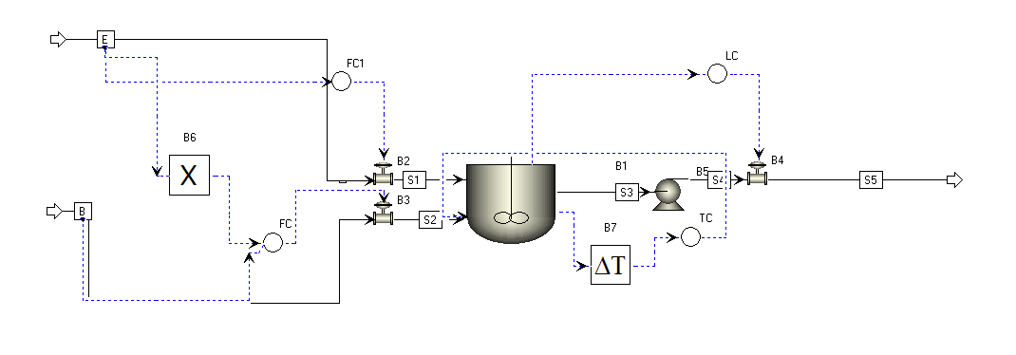

Controllers:

FC1: Flow rate control of ‘E’

FC2: Flow rate control of ‘B’ (cascade control, 2:1 mole ratio of B:E)

TC: Reactor temperature control (with 1min dead time)

LC: Reactor level control

To construct the dynamics surrogate model, model inputs are: all setpoints of controllers. Here the setpoint of LC is assumed to be the same and FC2 is a cascade control, so the resulting inputs of control setpoints are only FC1 and TC.

Additionally, the material inputs are temperatures of E and B (assume TCs are installed in both E and B). Coolant and temperature.

Model outputs are level and temperature of the reactor, flow rate of the product.

Fault scenarios (0-3h normal operation, introduce the fault at 3h):

1. Ratio of E:B increases (step change, increase E to 400 kmol/h)
2. Ratio of E:B decreases (step change, decrease B to 600 kmol/h)
3. Temperature increase of E (step change, increase to 60)
4. Temperature increase of B (step change, increase to 60)
5. Coolant temperature increases (step change, increase to 50)
6. Ratio of E:B (random variation of feed E +- 20)
7. Coolant temperature (random variation +- 5)
8. Coefficient of heat transfer in reactor (random variation)
9. Catalyst delay (random variation)
10. Coolant outlet valve of reactor (Sticking, flow rate maintains at 200000)
11. Product outlet valve of reactor (Sticking, flow rate maintains at 40%)

**Case 2:**

Separation of water and tetrahydrofuran (THF) using pressure-swing distillation.

The system studied is THF/water whose normal boiling points are 66/100 °C.

The total feed is 2000 kmol/h with 6/94 mol% composition at 30 °C and the purity requirements are 99.99/99.999 mol%.

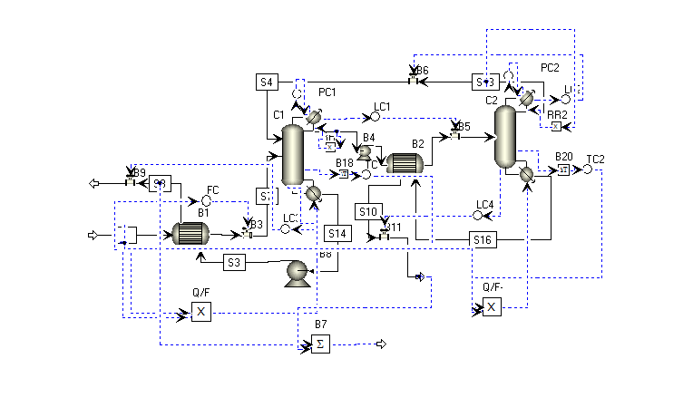

Controllers:

FC: Flow rate control of ‘feed’

PC1, PC2: Column 1,2 pressure control

TC1, TC2: Column 1,2 temperature control (with 1min dead time)

RR1, RR2: Column 1,2 reflux rate control

LC1, LC2: Column 1,2 condense drum level control

LC3, LC4: Column 1,2 level control

Model inputs are: all setpoints of controllers. Here the setpoints of all LCs are assumed to be the same. FC_SP, PC1_SP, PC2_SP, TC1_SP, TC2_SP, RR1_SP, RR2_SP

Additionally the temperature of the feed

Model outputs are PC1_PV, PC2_PV, TC1_PV, TC2_PV, distillate flows of columns 1 and 2, bottom flows of columns 1 and 2, reboiler duties of columns 1 and 2, temperature of feed.

